# CS 499 Module One Assignment

***Submitted by: Suvam Kharel***

1. **Self-Introduction:** Address all of the following questions to introduce yourself.
   1. How long have you been in the Computer Science program?

**I have been in the Computer Science program for over three years now but I have enjoyed coding for longer than that. My enrollment in the program has only deepened my knowledge and skillset in software engineering.**

* 1. What have you learned while in the program? List three of the most important concepts or skills you have learned.

**The most notable skills I would say are in full stack development where working on font end, creating UI, back end, managing server logic, APIs and databases were used to build applications. Database management was also very helpful in learning CRUD operations and optimizing databases along with the secure coding practices where I learned concepts like input validation, encrytption and authentication.**

* 1. Discuss the specific skills you aim to demonstrate through your enhancements to reach each of the course outcomes.

**Through these enhancements, I want to be able to implement proper input validation to prevent malicious entires, improve UI for better functionality and design so it can meet real world standrards. I also want to optimize the application’s efficiency and use data structures to enhance the data organization and expand the database to support event categorization.**

* 1. How do the specific skills you will demonstrate align with your career plans related to your degree?

**My career goals and responsibilities of an integration/test engineer or systems engineer are perfectly in line with the skills I learned in full-stack development, managing databases, and secure coding practices My understanding of software development allows me to assess product/software from both a functional and security perspective, ensuring they meet performance and security standards. My skill in database management helps in data integrity analysis, system efficiency optimization, and backend process validation. In addition, my understanding of secure coding techniques guarantees that I recognize vulnerabilities, implement security measures, and support reliable systems. These abilities enable me to work on complicated system testing, validation, and integration, ensuring that they satisfy industry standards and operate as intended, especially in high-security settings like aerospace and defense.**

* 1. How does this contribute to the specialization you are targeting for your career?

**These skills contribute directly to the area I am trying to specialize in. Systems engineers focus on improving the fucntionlity of the system, identify defects/vulnerability and optimize complex systems. Code review and improving the functionluty directly corresponds to such task. In industries like aerospace and defense, where constanrt updates are necessary to their systems and where we have to meet rigorous security standards, these skills are especially very important.**

1. **ePortfolio Set Up:**
   1. Submit a **screen capture** of your ePortfolio GitHub Pages home page that clearly shows your URL.

* 1. Paste a screenshot of your GitHub Pages home page with your URL clearly showing in the space below.

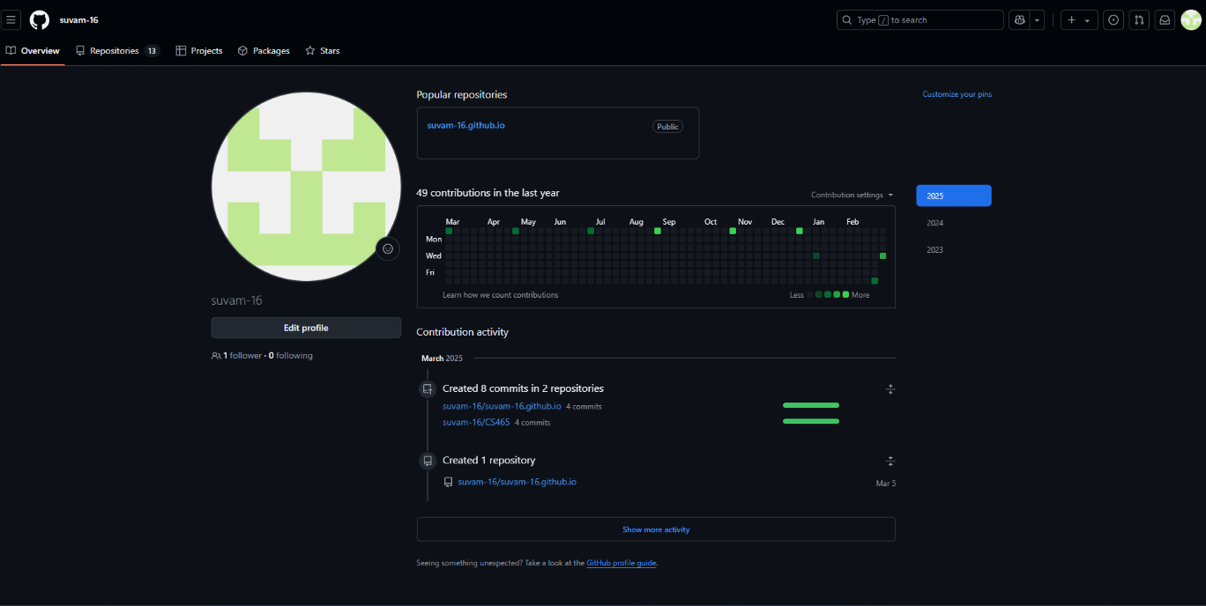

1. **Enhancement Plan:**
   1. **Category One:** Software Engineering and Design
      1. **Select an** **artifact** that is **aligned with** **the** software engineering and design **category** and explain its origin. Submit a file containing the code for the artifact you choose with your enhancement plan.

* **The artifact that I selected for this category is CS 360: Mobile Architecture and Programming. For this specific cagtegory I want to prioritize more on the UX/UI elements and I have decided to work on my existing Event Tracker Application that I built during this class and have decided to expand on its features to align more with the applications that are currently on the market adding more visually appealing modifications along with improving the database schema to include new feature such as event description and better animation styles to add to the visual appeal of the app.**
  + 1. **Describe** a practical, well-illustrated **plan** for enhancement in alignment with the category, including a pseudocode or flowchart that illustrates the planned enhancement.
* **To Improve the overall design of the Event Tracking App, I will implement the following enchancements:**

1. **Add background images to modernize the look of the app and take away from its simplistic nature.**
2. **Improve button styles for better aesthetic.**
3. **Implement dark mode support.**
4. **Add event description field so users can add event details as well.**
5. **Update database schema to include this new field.**
6. **Update animation effects for event deletion to add more visually appealing animations.**
   * 1. Explain how the planned enhancement will **demonstrate** specific **skills** and align with course outcomes.
        1. Identify and describe the specific skills you will demonstrate that align with the course outcome:

* **As part of enhancing my Event Tracking Application for the Software Engineering and Design category, I will demonstrate key skills in UI/UX design, software architecture, database management, theming, and animations. Additionally, I will expand the database schema by introducing an event description field, allowing users to store more detailed event information. Implementing dark mode support will make the app more accessible and adaptable to user preferences. I will introduce animations for event deletion, creating a smoother and more engaging user experience as well as visually appealing and modifying the overall app interface. These enhancements align with modern mobile development best practices, improving usability, maintainability, and performance.**
  + - 1. Select one or more of the course outcomes below that your enhancement will align with.
* **Demonstrate an ability to use well-founded and innovative techniques, skills, and tools in computing practices for the purpose of implementing computer solutions that deliver value and accomplish industry-specific goals.**
* **Design, develop, and deliver professional-quality oral, written, and visual communications that are coherent, technically sound, and appropriately adapted to specific audiences and contexts.**

Applicable Pseudocode example (Adding Event class that supports description):

**public class Event {**

**private int id;**

**private String name;**

**private String date;**

**private String description; // New field for event description**

**public Event(int id, String name, String date, String description) {**

**this.id = id;**

**this.name = name;**

**this.date = date;**

**this.description = description;**

**}**

* 1. **Category Two:** Algorithms and Data Structures
* **The artifact that I selected for this category is CS 360: Mobile Architecture and Programming as well. To meet the requirements, I have decided to improve the app functionality by implementing sort and search feature for the events in the app. The original design does not support any sorting and simply retrieves events from SQLite database. Sorting will be essential as priority events need to be shown fist and can be sorted in that manner. I also want to implement a search bar as a part of UI so users can look up the event based on name/date.**

1. **Describe** a practical, well-illustrated **plan** for enhancement in alignment with the category, including a pseudocode or flowchart that illustrates the planned enhancement.

* **To meet the requirement of the category, I will implement the following enhancements:**
  + - 1. **Implement sorting using SQLite’s ORDER BY to prioritizes events based on the preference of the user (For example: sorting my date, sorting by name, importance etc.)**
      2. **Implement Binary Search to implement faster event lookup based on user input.**
      3. **Implement search bar in the UI to support the search feature.**

1. Explain how the planned enhancement will **demonstrate** specific **skills** and align with course outcomes.
   1. Identify and describe the specific skills you will demonstrate to align with the course outcome.
   * For this category, I want to be able to demonstrate skills in algorithm optimization, efficient data structures and improvement of the app performance/functionality. As mentioned above, I will implement the sorting and searching features along with required UI elements to support the design and in turn, these changes will optimize the data retrieval, improve performance, and align with best practices in mobile application development.
   1. Select one or more of the course outcomes listed under Category One that your enhancement will align with.

* Design and evaluate computing solutions that solve a given problem using algorithmic principles and computer science practices and standards appropriate to its solution while managing the trade-offs involved in design choices.
* Demonstrate an ability to use well-founded and innovative techniques, skills, and tools in computing practices for the purpose of implementing computer solutions that deliver value and accomplish industry-specific goals.

Applicable flowchart example for sort feature in the app:

* 1. **Category Three: Databases**
     1. **Select an artifact** that is **aligned with the** databases **category** and explain its origin. Submit a file containing the code for the artifact you choose with your enhancement plan. You may choose work from the courses listed under Category One.
* **For the Databases category, I also chose CS 360: Mobile Architecture and Programming as well. The application currently makes use of SQLite, which keeps event data locally on the user's device. This method is good for offline use, but it doesn't allow remote access to event data or multi-device synchronization. By moving from SQLite to MySQL, I hope to improve the application's scalability and usability while enabling cloud-based storage and multi-device access to events.**
  + 1. **Describe** a practical, well-illustrated **plan** for enhancement in alignment with the category, including a pseudocode or flowchart that illustrates the planned enhancement.
* **The following steps will be taken to meet the requirements:**
  1. **Create an events table in MySQL to store event details.**
  2. **Write a backend API to handle event retrieval, insertion, and deletion using MySQL.**
  3. **Replace SQLite queries with HTTP requests to interact with MySQL through the API.**
  4. **Ensure event data is correctly stored, retrieved, and displayed in the app.**
     1. Explain how the planned enhancement will **demonstrate** specific **skills** and align with course outcomes.
        1. Identify and describe the specific skills you will demonstrate that align with the course outcome.
* **For this category, I want to be able to demonstrate skills in database management, API integration and cloud based storage solutions by switching from SQLite to MySQL. For this enhancement, a structured relational database must be designed, a PHP API must be created for the app and MySQL to communicate, and the Android app must be changed to communicate with the database via HTTP requests. These abilities enhance the application's scalability, multi-device accessibility, and data consistency while also being in line with industry standards.**
  + - 1. Select one or more of the course outcomes listed under Category One that your enhancement will align with.
* **Demonstrate an ability to use well-founded and innovative techniques, skills, and tools in computing practices for the purpose of implementing computer solutions that deliver value and accomplish industry-specific goals.**

Applicable flowchart to represent data flow:

1. **ePortfolio Overall Skill Set**
   1. Accurately describe the **skill set** to be illustrated by the **ePortfolio** **overall**.
      1. Skills and outcomes planned to be illustrated in the code review

* **In the code review, I will highlight my ability to analyze, refactor, and enhance existing code. This includes UI/UX improvements, sorting and searching optimizations, and database migration from SQLite to MySQL. The review will focus on code efficiency, maintainability, and security, demonstrating my proficiency in modern software development methodologies.**
  + 1. Skills and outcomes planned to be illustrated in the narratives
* **In the narratives, I will illustrate my problem-solving approach, technical decision-making, and project evolution. The narratives will explain why each enhancement was made, how it aligns with real-world software development challenges, and the impact on performance, scalability, and user experience. This will emphasize my ability to apply computer science principles to practical applications.**
  + 1. Skills and outcomes planned to be illustrated in the professional self-assessment
* **The professional self-assessment will reflect on my growth as a developer, my proficiency in full-stack development, and how my skills align with my career goals in systems engineering and software testing. It will highlight my experience with secure coding, database optimization, algorithm efficiency, and UI/UX improvements, demonstrating my readiness for industry roles that require analytical problem-solving and technical expertise.**